BauLynq
Ein Bauprojekt. Ein durchgängiger Datensatz.
One project. One continuous record — the platform that connects German construction.
Business Plan — Investor Edition
July 2026
info@baulynq.com · +49 1525 4966510 · www.baulynq.com · app.baulynq.com
Confidential. Unless stated otherwise, pricing, targets and projections are planning figures (Entwurf), status July 2026, to be validated with the H2 2026 pilot cohort. All monetary figures net of VAT (USt). This single disclaimer applies document-wide.

CONTENTS
Contents
01 Executive Summary
02 What Is Already Built
03 The Problem
04 Market & Why Now
05 Product — One Continuous Record
06 Competition
07 Go-to-Market & Pilot Design
08 Business Model & Pricing
09 Financial Plan
10 Team & Hiring
11 The Ask & Use of Funds
12 Risks & Mitigation
13 Exit & Return Potential
14 Data, Security & What We Report
15 Appendix — Sources & Verification

SECTION 01

Executive Summary
The product is finished and live; this round buys distribution, not development.
10+1 | 1,465 | 3 | 21 days | €500k
modules + task layer, live at app.baulynq.com | automated backend tests, verified in-repo | founding engineers — the platform written by one of them | first-module go-live target per company | proposed seed — an acceleration instrument

BauLynq is a German construction-technology platform that replaces the industry's fragmented Excel-and-e-mail data chain with one continuous project record. The Leistungsverzeichnis (LV — the bill of quantities) is the backbone: tender, award, execution, billing and handover all read and write the same dataset. Ten modules plus a cross-cutting task layer are built and live at app.baulynq.com, with 1,465 automated backend tests (verified in the repository on July 18, 2026) — engineered by founder Mohamad El Ejel and carried by a three-engineer founding team from the construction industry.
The problem is worth paying for. A mid-market contractor closes its month in ~10 days of spreadsheets and phone calls; every phase handover re-types the project and loses variations (Nachträge) — margin that was already earned on site. The moment is regulated: since 2025 every German B2B company must receive e-invoices; from 2027 issuing becomes mandatory above €800k prior-year turnover, from 2028 for all domestic B2B. The mandate does not sell a platform — but it forces every target firm to touch its invoicing process at exactly the moment a switching conversation is possible.
The positioning is national, and deliberate. The leading cloud construction-management platforms are American — Procore ($1.32bn revenue FY2025, 17,850 customers) and Autodesk Construction Cloud prove the category at scale. Neither advertises native support for the German stack (GAEB, VOB billing, REB, XRechnung, GoBD); Procore has no EU application zone at all — European application data is processed in the UK, estimating data in the US. BauLynq is the German answer: built from Germany, for German construction law, on German soil (Azure EU, Germany) — first for the German Mittelstand, then outward. DATEV and Personio show how this playbook ends: the localized German champion wins the home market the US incumbent cannot crack.
The plan is capital-efficient in both directions. Self-funded (base case), BauLynq reaches ~96 customers and ~€1.18m ARR by end-2028, EBITDA-positive during 2028, with a peak cash need of ~€277k. The €500k seed is an acceleration instrument: pulled-forward sales capacity and marketing lift the same machine to ~145 customers and ~€2.0m ARR end-2028 (+€0.8m ARR vs. base). Even the conservative case — 40% fewer sales, 2% monthly churn, hiring re-phased — stays within the round.
End of 2028 | Conservative | Base (self-funded) | Funded acceleration | Zielbild (draft)
Customers | 54 | 96 | 145 | 105
ARR (run-rate) | €0.58m | €1.18m | €2.00m | €1.74m
EBITDA 2028 | −€108k | +€128k | +€656k | +€495k
Peak pre-funding cash need | €310k | €277k | €206k | €201k

Pilot cohort H2 2026 (8 companies, special terms, 21-day first-module go-live target) → paying reference customers 2027 → the platform the Mittelstand switches to as the mandate broadens in 2028, with DACH expansion as upside.
SECTION 02

What Is Already Built
An unusually large asset for a pre-revenue company — verified in the repository, not claimed.
Verified fact (as of July 18, 2026) | Detail
Live product | app.baulynq.com (frontend) · api.baulynq.com (backend); public site www.baulynq.com
12 module areas in production code | BidX · InrX · FleetX · CrewX · ReportsX · SUBX · ProcureX · LedgerX · TED · PlanX · BIM · Aufgaben, plus admin
1,465 automated backend tests | [Fact]/[Theory] methods counted in BauLynq.Tests: GAEB round-trips, REB formulas, payroll, billing gates, German number handling
Authentication & permissions | AuthContext / RequireAuth / role permissions present in the frontend
Architecture | .NET 10 clean architecture; React 19; German-first with full English localization; EUR/de-DE domain
Foundation core | Projects (HOAI LP1–9), sites, AG/AN party axis, LV tree with OZ addressing, DIN 276 cost groups, ATV measurement rules

The platform code was written by one engineer in roughly two years — a scope that funded teams typically approach with several million euros of venture capital — and the company behind it is a three-engineer founding team. The consequence for an investor: €500k here buys go-to-market for a finished product, not product risk. Deep specialist logic is concentrated where it wins deals — BidX and InrX, the GAEB/VOB/REB tender-and-billing core no point solution offers — while the surrounding modules provide connected adequacy on the same record; the moat is the continuous record, not ten best-of-breeds.
SECTION 03

The Problem
Every phase handover re-types the project and leaks earned margin.
The problem is not the construction site — it is the way project data travels. Each phase keeps its own spreadsheets: the tender LV in one file, work preparation in another, site measurements in PDFs, timesheets in a third workbook. Files named "Abrechnung_final_v7.xlsx" and "Nachtrag_neu_NEU.xlsx" are the industry's actual system of record.
- Transfer errors — quantities and prices drift between tender LV, contract LV and billing sheets.
- Lost variations — Nachträge raised on site never reach the final invoice.
- Duplicate master data — subcontractors, machines and cost codes maintained in parallel lists.
- A ~10-day month-end close — spreadsheets and phone calls instead of a report.
Every re-key loses accuracy; every loss is margin the company had already earned.
SECTION 04

Market & Why Now
≈4,540 German firms must touch their invoicing process by 2028; BauLynq needs 100 of them.

4.1 Market size — counted bottom-up
Metric | Value | Source
German construction volume (Bauvolumen) | ≈ €560bn / year | DIW Bauvolumenrechnung (2024: €554.8bn; 2026e: €584bn)
Firms (WZ F) 50–249 employees | 4,310 | Destatis Unternehmensregister 2024 (verified)
Firms (WZ F) 250+ employees | 385 | Destatis Unternehmensregister 2024 (verified)
Target band 50–500 employees (SAM) | ≈ 4,540 firms | Model estimate (60% of the 250+ band ≤500)
SAM value | ≈ €56–81m ARR | Blended ARPA (€56m) to full-platform (€81m)
100 customers by end-2028 | ≈ 2.2% of SAM | Deliberately conservative penetration

Beyond the German SAM, three expansion vectors carry the ceiling toward a €300m+ TAM: (1) DACH — an estimated ~1,750 additional 50–500-employee firms in Austria and Switzerland from 2028; (2) ACV expansion — an Enterprise tier and seat overage lift ceiling ARPA from €17.9k toward €40–60k for 250–500-employee firms; (3) the 10–49-employee band (≈30k firms) with a lighter SKU after 2028.

4.2 Why now — three legs, not one
- Regulation forces contact (the door-opener). E-invoice receiving is mandatory since Jan 2025; issuing becomes mandatory Jan 2027 for firms above €800k prior-year turnover and Jan 2028 for all domestic B2B. The mandate itself can be satisfied with a €20/month converter — it does not buy platforms. What it does is force every target firm to open its invoicing process at a known date. The purchase reason is the 10-day close and the lost Nachträge; an e-invoice generated from a wrong Excel quantity is a compliant wrong invoice.
- Margin pressure makes the leak acute. After the 2023–2025 downturn, mid-market contractors cannot afford billing leakage; DIW forecasts real construction growth returning (+1.7% 2026, +3.4% 2027) — recovery volumes on broken data chains.
- Generational handover. Mittelstand succession is putting digital-native owners in charge of Excel-run companies; cloud acceptance in construction has crossed the threshold.
Standing obligations — GoBD immutability, DSGVO — apply regardless of the e-invoicing calendar, so the demand driver survives a deadline slip.

4.3 The sovereignty moment — a German tool for a German industry
A fourth force is now measurable. Bitkom's Cloud Report 2026 (603 German companies surveyed): 85% say Germany is too dependent on US cloud providers (up from 78% in 2025), 91% would prefer a German cloud provider, 37% would accept trade-offs for Germany-only data protection, and 12% would even pay 10–20% more. The state is moving the same way — Delos Cloud (SAP/Microsoft/Arvato) is building the sovereign cloud for German public administration, and the EU Commission published a Cloud Sovereignty Framework for procurement in 2025.
Construction management is exposed to exactly this concern: the category's global leaders are American. Procore processes European application data in the UK (it operates no EU application zone; estimating data is processed in the US), and Autodesk's Germany data residency (announced June 2025) covers only part of its portfolio — Docs and BIM Collaborate, not the full Construction Cloud suite. Neither advertises GAEB, VOB billing, REB or XRechnung support; German AVA/GAEB software directories list exclusively German-speaking vendors. A German contractor's project record — his prices, his margins, his audit trail — currently either stays in Excel or crosses the Atlantic.
BauLynq's answer is structural, not rhetorical: German domain model (GAEB · VOB · REB · GoBD at the core, not as a partner plug-in), German hosting (Azure EU data zone, Germany), German-language support, transparent German pricing — against Procore's opaque, construction-volume-linked contracts (third-party estimates: ~$10–15k/yr entry, $30–80k/yr mid-market). The precedent is proven: DATEV owns German tax software against Intuit; Personio won European mid-market HR against Workday and BambooHR — both by making German compliance the product, not a feature. Nemetschek (€1.19bn revenue FY2025) proves a German AEC software company can scale globally. The sequence is the same one: from Germans, for Germans — then for the world, starting with DACH in 2028.
SECTION 05

Product — One Continuous Record
The LV is the backbone: every phase deepens the same dataset instead of re-typing it.
The tender LV becomes the contract LV; site measurements post directly into billing; variations stay linked to the positions they amend. All modules plug into one foundation core: projects with HOAI phase lifecycle, sites, parties on the AG/AN axis (which drives permissions and workflows), the LV tree with OZ addressing, DIN 276 cost groups, and per-trade ATV measurement rules.
Module | Scope
BidX (spike) | Tendering & award — GAEB X81–X86 import, LV calculation, bid comparison, award in one click
InrX (spike) | Measurement & VOB billing — Aufmaß, progress claims, variations, retention
FleetX | Machines — fleet, fuel, maintenance, BGL, internal charging
CrewX | Crew — attendance, leave, time recording, payroll
ReportsX | Reports & exports — KPIs, e-invoicing, site diary
SAM | Subcontractors — contracts, credentials, verification
PAM | Procurement & materials — requisitions, orders, warehouse, suppliers
LEA | Payment plans & due dates
Planning | Schedules & work calendars
BIM | Model management — classification, LV mapping, model diff
Aufgaben | Cross-cutting task layer across all modules

Compliance is the foundation, not an add-on: GAEB, VOB, DIN 276, HOAI and REB govern the domain logic; XRechnung, GoBD immutability and DSGVO govern the records. Hosting on Azure in the EU data zone (West Europe). AI-assisted features carry an "AI-generated" label per EU AI Act Art. 50 (applicable from Aug 2, 2026).

5.1 Post-funding product roadmap (18 months)
- DATEV export & accounting integration — table stakes for the Mittelstand's tax advisors; first roadmap item after close.
- E-invoice transmission channels (Peppol, e-mail routing) beyond format generation.
- Mobile / offline site capture — construction sites have unreliable connectivity.
- Open API layer for ERP/accounting interoperability; then Enterprise-tier features (SSO, on-premise).
SECTION 06

Competition
US platforms lead the category but not the German stack; the sovereign continuous record in the middle is open.
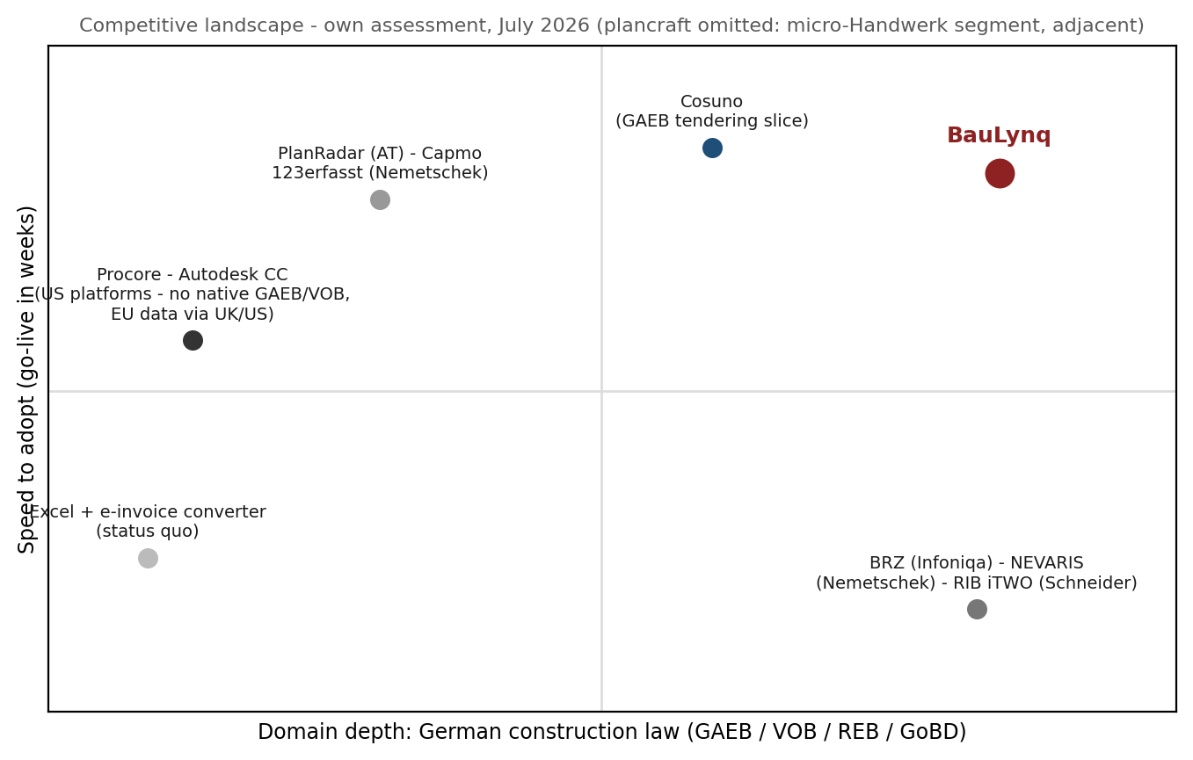
Group | Players | Strength | Why they don't own the middle
US platforms | Procore ($1.32bn rev. FY2025, 17,850 customers) · Autodesk Construction Cloud (AECO $3.58bn FY2026) | Category-defining breadth, capital, brand | Neither advertises native GAEB / VOB billing / REB / XRechnung support; Procore runs no EU application zone; ACC's Germany residency covers only part of the suite. Priced on construction volume — estimates $10–80k/yr, opaque. Procore's German launch (Nov 2022) has produced no disclosed German customer base.
German construction ERP | BRZ (Infoniqa since Mar 2025) · NEVARIS (Nemetschek) · RIB iTWO (Schneider Electric) | Master German construction law; incumbency | Their revenue model is the implementation project — services-attached licences paid in project days. A 21-day self-serve product cannibalizes their economics; none of the three is independent anymore.
Slice specialists | Cosuno (GAEB tendering, ~€45m) · PlanRadar (AT) · Capmo · 123erfasst (Nemetschek) | Fast in their slice; Cosuno is the closest direct overlap | Each digitalizes one phase and creates a new data island; none carries the record from tender through VOB billing to GoBD archive. Cosuno stops at award — exactly where the margin leak begins.
Status quo | Excel + a cheap e-invoice converter | Free, familiar — the real competitor in most deals | Satisfies the mandate but not the month-end; every compliant wrong invoice keeps the margin leak open.

Adjacent, not competing: plancraft (Hamburg, >€50m raised) is office software for micro/small Handwerk businesses — quoting and invoicing for firms mostly under 20 employees. Different buyer, different workflow; its funding validates German ConTech capital appetite rather than threatening the 50–500-employee GC segment. Craftnote (HVD Group) sits in the same Handwerk segment.
Pre-empting the obvious question: yes, Germany already has AEC software champions — Nemetschek (€1.19bn revenue) and RIB prove the market. But they sell design tools, estimating ERPs and implementation projects; none offers a cloud continuous record from tender to GoBD archive at Mittelstand price points. Honest read: the middle stays open while US platforms lack the domain model, ERPs protect services revenue, and slice players broaden — a window we estimate at ~24 months. BauLynq's job is to convert it into reference customers before it closes.
SECTION 07

Go-to-Market & Pilot Design
Land one module in 21 days, expand to the platform — the funnel math is stated, not implied.

7.1 The funnel (2027 steady state)
Stage | Assumption | Monthly result
Qualified leads (founder network, pilot referrals, inbound) | 40 / month | 40
Lead → demo ("30 minutes, a working session") | 30% | 12 demos
Demo → close (pilot-led, ~3-month cycle) | 25% | 3.0 closes
Plan average actually used in the model | — | 2.5 / month (ramp headroom for AE #1)

Sales motion: direct, demo-first, on the prospect's own project data. Land with one module (Starter, €490/month) — usually BidX or InrX where the pain is sharpest — and expand toward the full platform (Professional, €1,490/month) as adjacent phases join the record. Expansion is modeled explicitly: 1%/month of the Starter base upgrades in the base case, driven by an in-product path, not hope. Partner channels (tax and construction-law advisors) are a 2027 option once references exist.

7.2 Pilot cohort H2 2026 — design
Parameter | Value
Cohort size | 8 companies (2 in July, ramping to 8 by November 2026)
Selection | Mid-market GCs and developers with live projects and Excel-based billing; mixed trades
Terms | €250 / month special pilot fee; close support; conversion to paid at €1,000 one-time fee
Success criteria per pilot | First-module go-live ≤21 days · one full billing cycle on the platform · reference agreement
Target conversion | 75% to paying customers in January 2027 (base case)

The 21-day go-live — precisely scoped
Days 1–5: data migration (GAEB import of current LVs, master data). Days 6–10: training on the first module. Days 11–21: first live billing run in parallel with the old process. Scope: first productive module (BidX or InrX) on one live project — not full-suite rollout. Payroll (CrewX) is explicitly outside the 21-day scope; full platform expansion runs 3–6 months per the land-and-expand path. The pilot cohort exists to prove this number before it is headlined.

Onboarding capacity is planned, not assumed: at 3–4 go-lives per FTE per month, the 2028 base case (~65 gross adds) needs two dedicated onboarding people — both are in the hiring plan (Feb 2027 and Jul 2028). Onboarding revenue (€2.5k/€5k one-time) is priced accordingly and reported separately from subscriptions.
SECTION 08

Business Model & Pricing
Recurring per-module, per-seat revenue; a 3× expansion path inside every account.
- Recurring revenue: monthly subscription per module and seat, bundled into three tiers — predictable for the customer, MRR for BauLynq.
- Land and expand: start at €490/month, grow to €1,490/month (3.0× ACV) as modules and seats are added — expansion without acquisition cost.
- One-time onboarding & data migration: €2,500 (Starter) / €5,000 (Professional) — covers delivery, filters unserious prospects, reported separately.
Tier | Price | Includes
Starter | €490 / month | 1 module · up to 5 seats · hosted in the EU
Professional | €1,490 / month | All 10 modules · up to 25 seats · e-invoicing & GoBD archive
Enterprise | On request (annual) | Unlimited seats · on-premise option · SLA — roadmap 2027; lifts ACV ceiling toward €40–60k

Why not cheaper (the pricing rationale): visible low anchors — PlanRadar bundles from ~€89–129/month, Craftnote ~€30/seat — are the wrong comparison set: per-seat prices for single-slice documentation apps sold substantially into the Handwerk segment. Starter is a flat per-company price for an ERP-grade compliance module (GAEB import, VOB billing logic, GoBD archive) aimed at firms with 50–500 employees, where the relevant alternatives cost more, not less: construction-ERP seats run to thousands of euros per year and Procore's entry is ~$10–15k/yr (third-party estimates). One recovered Nachtrag pays for years of Starter. A cheaper self-serve tier is explicitly rejected — VOB billing cannot responsibly be self-served, it would anchor the platform at point-tool prices, and it would break the 3× expansion path. The €250/month pilot fee is the deliberate low-cost on-ramp, and pricing is a stated pilot-cohort validation goal: the model shows a €100 Starter price cut moves base-case 2028 ARR by only ~4%, so pricing risk is small next to sales-execution risk.
Why customers stay (the churn argument): BauLynq holds the system of record — the LV history, measurement chains and the GoBD-immutable billing archive. Leaving means exporting a legal audit trail mid-project. Combined with annual contracts from 2027, the base case assumes 1.25% monthly gross churn (~14%/year) — deliberately above the promo's draft (0.75%) and in line with SMB/mid-market vertical-SaaS benchmarks; the conservative case carries 2.0%.
Customer segments (who buys): mid-market general contractors 50–500 employees (core), developers (cost per unit), infrastructure (resources across sections), industrial & energy (handover documentation). The unifying trait: they bill with Excel today and must issue e-invoices tomorrow.
SECTION 09

Financial Plan
Self-funded, the plan reaches €1.18m ARR; funded, the same machine reaches €2.0m — modeled monthly, taxed, and stress-tested.
The delivered workbook (BauLynq_Financial_Model.xlsx) models July 2026 – December 2029 monthly: cohort-based tiers with explicit Starter→Professional upgrades, sales commissions, wage inflation, a 10% contingency on every cost line, simplified corporate tax with loss carryforward, post-funding cash balance and runway, a churn × sales-plan sensitivity grid, and four scenarios. ARR counts subscriptions only — pilot fees are never annualized.
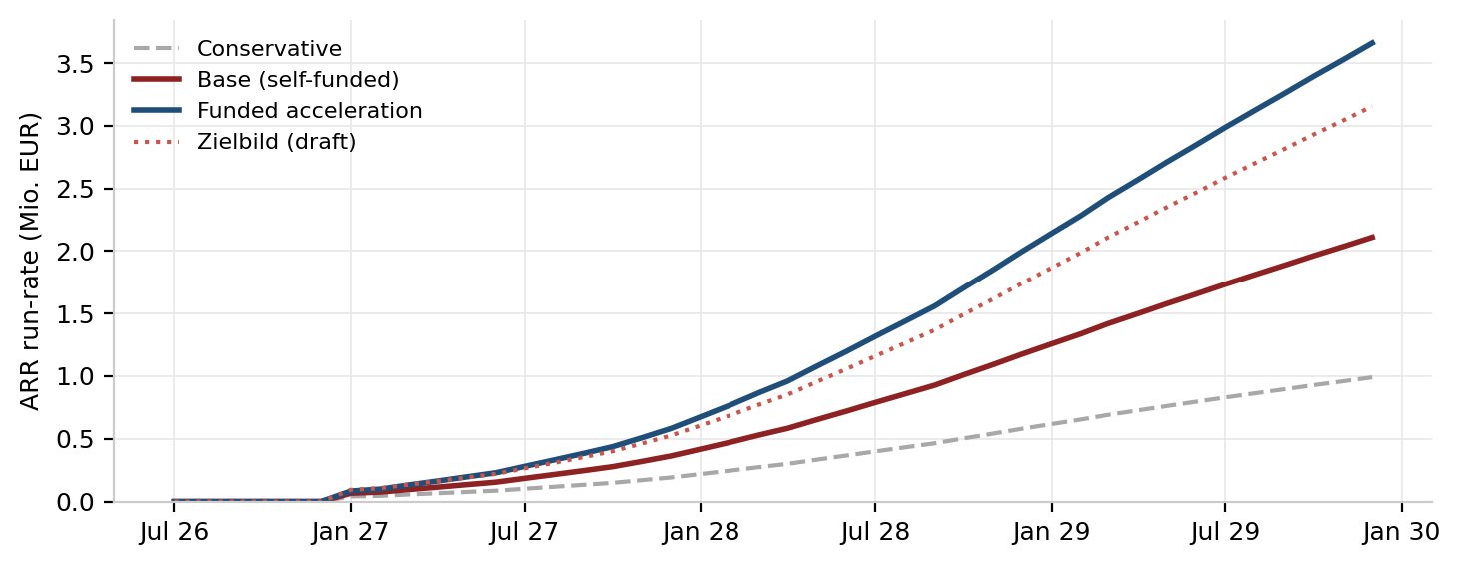

9.1 Base case (self-funded), annual view
 | 2026 (H2) | 2027 | 2028 | 2029
Customers (EOY) | 8 pilots | 34 | 96 | 161
ARR (EOY run-rate) | — | €364k | €1.18m | €2.11m
Total revenue | €8k | €298k | €1.04m | €2.03m
of which subscriptions | — | €187k | €769k | €1.69m
of which onboarding (one-time) | — | €110k | €272k | €336k
Personnel costs | €51k | €280k | €569k | €680k
S&M costs (CAC basis) | €26k | €197k | €375k | €439k
Total operating costs | €84k | €477k | €914k | €1.13m
EBITDA | −€75k | −€180k | +€128k | +€895k
Tax (KSt+GewSt, simplified) | — | — | — | €230k
Cash balance (EOY, post-funding) | €15k | €335k | €463k | €1.13m
Headcount (EOY) | 2 | 4 | 7 | 7

Shape: a founder-funded pilot half-year (opening contribution €90k covers H2 2026), an investment year 2027 (−€180k EBITDA — the seed's job), operating leverage from 2028 as the mandate broadens and the installed base upgrades. S&M runs at ~40–66% of revenue in 2027–2028 — a real go-to-market budget, not a rounding error.
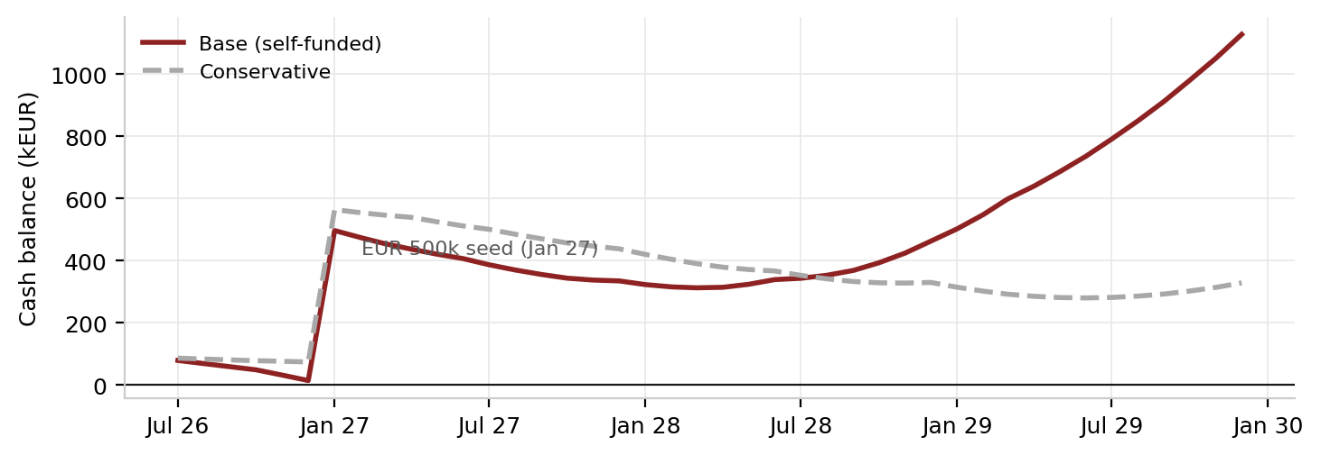

9.2 Unit economics (base case, 2028)
Metric | Value | Note
ARPA (blended subscription MRR) | €1,025 | 60/40 Professional/Starter mix at end-2028
Gross margin (run-rate) | 84% | MRR less hosting, payment fees and support personnel
CAC | ≈ €5,300 | Full S&M: marketing + commissions + sales compensation, ÷ gross adds
Monthly gross churn | 1.25% | ~14%/year — benchmark-anchored, above the promo draft
LTV (lifetime capped at 48 months) | ≈ €41k | ARPA × gross margin × capped lifetime — no 11-year lifetimes
LTV / CAC | ≈ 7.8× | Benchmark: ≥3× fundable, ≥5× strong (High Alpha 2024; Tidemark 2025)
CAC payback | ≈ 6.1 months | Under the <18-month credibility bar for SMB vertical SaaS

9.3 Stress test
The workbook's sensitivity grid varies churn (0.5–2.0%/month) against the sales plan (40–120%) while holding the personnel plan constant. Under that fixed-hiring constraint the worst cell at ≥60% plan attainment needs €598,933 and the absolute worst corner (2.0% churn × 40% plan) needs €1,021,390 — both above the €500k round. Both are precisely the cases in which hiring is re-phased, which is what the conservative scenario does: with a 6-month hiring delay the peak need falls to €310k and minimum post-funding cash stays positive at +€74k. The round is therefore sized against the conservative scenario, not against the fixed-hiring grid; the grid is shown so the constraint is visible rather than implied.
SECTION 10

Team & Hiring
Three founding engineers built the company; four hires scale it — each with a date, a cost and a trigger.
BauLynq is founded by three engineers:
- Mohamad El Ejel — Founder, Product & Engineering. Knows the Excel reality from his own construction project work; designed and wrote the entire platform: eleven module areas, the foundation core, 1,465 automated tests, live in production.
- Salah Alabdallah — Co-founder, Construction & Operations. Engineer, currently at Deutsche Bahn — brings large-infrastructure operations discipline and the client-side (AG) process perspective; full-time transition planned with the round.
- Majd El Ejel — Co-founder, Engineering. Mechanical Engineering, Otto von Guericke University Magdeburg — engineering capacity and QA alongside the platform author.
Industry knowledge and product execution inside one founding team is the company's core capital efficiency. The concentration that remains — the platform code was written by one of the three — is addressed head-on below rather than hidden.
Founding-team capacity, H2 2026 (honest view): Mohamad — pilots and onboarding ~50%, product ~30%, sales alongside AE #1 ~20%; Salah — operations and pilot-site relationships alongside his current role; Majd — engineering support. The first thing that breaks at scale is onboarding — which is why the first two non-sales hires are onboarding/support, and why go-lives per FTE (3–4/month) gates the sales plan, not the reverse.
Role | Start | Loaded cost / yr | First-90-days mandate | Trigger
Sales / AE #1 | Nov 2026 | ≈ €85k | Own the demo→pilot funnel; 20 demos | Pilot cohort live
Onboarding & Support #1 | Feb 2027 | ≈ €67k | Own the 21-day promise; runbooks | >5 paying accounts
Engineer #1 | Jul 2027 | ≈ €104k | DATEV export; reduce bus-factor to 2 | ≥€15k MRR
Sales / AE #2 | Jan 2028 | ≈ €85k | Second territory (South/West) | AE #1 at quota
Support #2 · Engineer #2 | Jul 2028 | ≈ €171k | Scale onboarding to ~6 go-lives/mo; API layer | ≥60 accounts

Continuity measures (code-level key-person risk): the company-level bus factor is three, but the platform itself was written by one engineer — hence documented runbooks and architecture, credential escrow, key-person insurance at closing, and Engineer #1 explicitly mandated to reach shared code ownership. 1,465 tests and a clean architecture make the codebase transferable; the hires make it shared. Two to three advisors (a Mittelstand construction operator, a SaaS go-to-market advisor) are being recruited alongside the round.
SECTION 11

The Ask & Use of Funds
€500k turns a self-sustaining €1.2m-ARR plan into a €2.0m-ARR plan — and de-risks the downside for free.
Use of funds | Amount | What it buys
Core team (4 hires through 2027) | €330k | Sales, onboarding ×1, engineering — the three seats the promo names
Go-to-market & marketing | €90k | Trade fairs (BAU/digitalBAU), content, paid acquisition — the 2027–28 funnel
Infrastructure, certification & buffer | €80k | Hosting scale-up, ISO 27001 track, key-person insurance, reserve

- Milestone the round buys: ≥34 paying customers and ≥€364k ARR by end-2027 (base) — Series-A-ready — or, in the funded case, ~50 customers and the 2028 leverage point pulled forward.
- Runway: through cash-flow positive in all four scenarios; minimum post-close cash never goes negative (conservative: +€74k at trough with hiring re-phased).
- Corporate & IP (commitments at closing): operating entity finalized at close; all IP assigned to the company; founders accept standard 4-year vesting; no debt; fully owned by the founding team today (split documented at closing).
The €500k is sized from the model: ~1.6× the conservative-case peak need, with the remainder explicitly buying the acceleration delta (+~€0.8m ARR end-2028 vs. self-funded). Instrument and valuation to be discussed; the plan works at seed-standard terms.
SECTION 12

Risks & Mitigation
The plan models its own failure modes — including the one where customers buy a €20 converter instead.
Risk | Mitigation
Customers satisfy the e-invoice mandate with minimal tools (DATEV, converters) and keep Excel | Priced in: the mandate is treated as door-opener only; the sales case is month-end close and Nachträge recovery, demonstrated on the prospect's own project in the demo
Key-person: the platform code was written by one engineer | Company-level bus factor is three; code-level: runbooks, credential escrow, key-person insurance at close, Engineer #1 mandated to shared ownership; 1,465 tests make the code transferable
Sales execution: ~30 logos in 2027 with 1 AE | Funnel stated (40 leads → 12 demos → 2.5–3.0 closes/mo); conservative case (0.6× plan, 2% churn, hiring re-phased) still fits inside the round
Churn and pricing untested | Pilot cohort exists to measure exactly this before scaling spend; churn already set above draft (1.25% vs 0.75%)
Competitive response (US platforms localizing, ERPs down-market, Cosuno broadening) | ~24-month window stated honestly; a US platform building GAEB/VOB/REB/GoBD natively is a multi-year effort with no announced start; references and the GoBD-archived record are the lock-in being built
Regulatory timing slips | Two of three demand legs (margin pressure, generational handover) and GoBD/DSGVO stand independent of the e-invoice calendar
True downside: pilots don't convert | Stop-loss plan: hold at 2 FTE, wedge-module pricing (BidX/InrX only), €500k then funds 30+ months of runway to find product-market fit

SECTION 13

Exit & Return Potential
German construction-law depth is what global platforms acquire rather than build.
The category clears venture outcomes: Autodesk paid $875m for PlanGrid; Procore ($7–8bn market cap) and Autodesk both need German-stack depth to win DACH and have bought rather than built before; Nemetschek is a serial acquirer that already bought 123erfasst and owns NEVARIS; RIB was acquired by Schneider Electric; BRZ was just consolidated into Infoniqa (2025). Recent category validation: PlanRadar's $69m Series B, Cosuno's ~€45m, plancraft's >€50m (adjacent Handwerk segment), Ecoworks' €40m round (2026).
BauLynq's specific acquirer logic: a GAEB/VOB/REB-native continuous record with a GoBD archive is exactly the asset a global construction platform needs for the German market and cannot assemble quickly. The realistic exit corridor for a focused execution is a strategic acquisition at €30–80m within 5–7 years (2–4× the SAM-implied ARR at 20–30% penetration and vertical-SaaS multiples of 5–8× ARR) — a 20–60× corridor on a €500k seed at standard terms. This is a scenario, not a promise; it is stated so the return logic can be interrogated.
SECTION 14

Data, Security & What We Report
Sold on compliance, run on compliance — and measured monthly.
- Hosting & data: Azure EU data zone (Germany); encryption in transit and at rest; role-based access on the AG/AN axis; per-customer data isolation.
- Compliance operations: GoBD Verfahrensdokumentation for the archive, AVV/DPA templates and subprocessor list maintained for customers' tax advisors; DSGVO by design.
- Security roadmap: external penetration test and ISO 27001 certification track budgeted for 2027.
- KPI reporting to investors (monthly): demos held, pilot conversions, actual days-to-go-live vs. 21-day target, MRR by tier, logo & net revenue retention, gross adds vs. plan, burn and runway.
SECTION 15

Appendix — Sources & Verification
Every external number has a source; every internal number has a workbook cell.
- Financial model: BauLynq_Financial_Model.xlsx — monthly model, 4 scenarios, sensitivity grid, unit economics, market sizing. The numeric source of truth for §9.
- Destatis Unternehmensregister 2024 (firm counts, verified Jul 18, 2026); DIW Bauvolumenrechnung — Wochenbericht 1+2/2025 (produced for the federal BBSR).
- E-Rechnung: BMF FAQ — receiving since 1 Jan 2025; issuing 1 Jan 2027 for > €800k prior-year turnover; 1 Jan 2028 all domestic B2B (second BMF letter, 15 Oct 2025).
- EU AI Act Art. 50: applicable 2 Aug 2026; Digital-Omnibus (May 2026) kept Art. 50, watermarking grandfathered to 2 Dec 2026.
- Competitive facts (re-verified online, Jul 18 2026): Procore FY2025 revenue $1,323m / 17,850 customers / no EU application zone; Autodesk AECO $3,583m FY2026, partial Germany residency; 123erfasst → NEVARIS/Nemetschek; BRZ → Infoniqa (2025); Craftnote → HVD (2024); PlanRadar $69–70m Series B; Capmo independent; Cosuno ~€45m; plancraft >€50m (micro-Handwerk); Nemetschek FY2025 €1,191m.
- Sovereignty: Bitkom Cloud Reports 2025/2026 (n=603–604); Delos Cloud; EU Cloud Sovereignty Framework (2025). Champions: DATEV (>€1.5bn revenue 2024); Personio (~$8.5bn valuation).
- SaaS benchmarks: High Alpha 2024; Tidemark Vertical & SMB SaaS 2025.
- Product verification (Aug 3, 2026): 1,465 [Fact]/[Theory] test methods; 12 module areas + auth in frontend source; built and running at app.baulynq.com.

